**EXERCISE NO:4**

**DATE:15/10/2020**

**AIM:**

To print a single string from two set of strings received from user and swap the first two characters of each string.

**PROGRAM:**

a = input()

b = input()

s1 = a.strip()

s2 = b.strip()

x = a[0:2]

a = a.replace(a[0:2],b[0:2])

b = b.replace(b[0:2],x)

if(len(s1)>=2 and len(s2)>=2):

print(a,b)

else:

print("Invalid")

**LINK:** <http://103.53.53.18/mod/vpl/forms/edit.php?id=234&userid=1695>

**OUTPUT:**

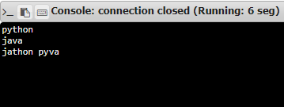

**RESULT:**

Thus the first two characters of a given string is swapped and displayed.